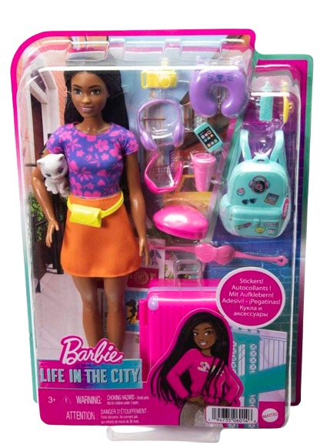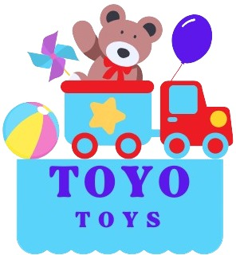

**Barbie Brooklyn**

**$9.99**

**Where dreams meet the stage!**

**Join Barbie Brooklyn on her musical journey! This doll captures the spirit of creativity and passion with her chic style and love for performing. A perfect companion for any child who dreams big.**

**Product details**

**THANK YOU!**

**WELLCOME TO OUR WEBSITE**